Jesus Take The Wheel (B)
.
.
Count: | 32 | Wall: | 4 | Level: | High Beginner | .  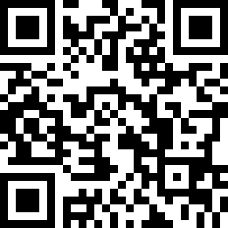
Choreographer: | Liselotte Øgaard (DK) - February 2017
Music: | Jesus Take the Wheel (And Drive Me to a Bar) - Sam Outlaw : (iTunes)
.

(16 counts intro). 1.Tag and a Restart on the 9 wall.

S1: (R) Side Chasse Back Rock, Vine ¼ Turn (L) Scuff.
1&2 | Step right to right side, step left beside right, step right to right side
3-4 | Rock back left, recover on right.
5-6 | Step left to left side, step right behind left
7-8 | ¼ turn left, scuff right. (9.00)

S2: Right Rock Recover ,Step Back (R) Step Back (L) Slow Coaster step (R) Touch (L).
1-2 | Rock forward on right, recover on left
2-3 | Step back on right, step back on left
5-8 | step back on right, step left beside right, step forward on right, touch left beside right. (9.00)
TAG: On the 9th wall at the end of S2: There will be a Tag on 8 counts, the music will stop and the singer speaks shortly = Make a rocking chair (R) and a jazzbox (R) with a cross (L) over right. Then Restart the dance. (9.00)

S3: Step (L) Side Hold Back Rock, Step (R) Side Hold Back Rock
1-2 | Step left to left side hold
3-4 | Rock back on right, recover on left
5-6 | Step right to right side hold
7-8 | Rock back on left, recover on right (9.00)

S4: Left Rock Recover, ½ Turn Left Shuffle, Jazz box Cross
1-2 | Rock forward on left, recover on right
3&4 | Turn ¼ left stepping left to left side, step right next to left, step ¼ turn left stepping forward left.
5-6 | Cross right over left, step back on left
7-8 | step right to right side, cross left over right (3.00)

Have fun - Feb. 2017.

Contact: dobiedeb@hotmail.com

