Love Like The Films AB
.
.
Count: | 16 | Wall: | 4 | Level: | Absolute Beginner | .  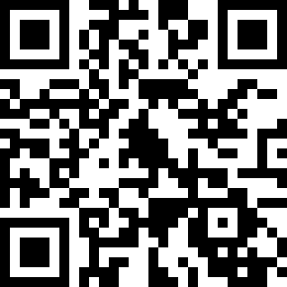
Choreographer: | Maryse Fourmage (FR) & Angéline Fourmage (FR) - November 2019
Music: | Love Like the Films - Lee Jae Jin (イ・ジェジン) : (from FTISLAND)
.

Start : 16 counts – 3 Tag
Sequence : A-A-A-Tag 1-A-A-A-A-Tag 1-A-A-Tag 2-A-A-A-A-A

[1-8] : Walk Backx2, Stompx3, Mambo,Toe Strut
1-2 | RF Back, LF Back
3&4 | Stomp RF next to LF, Stomp LF next to RF, Stomp RF next to LF
5&6 | Mambo L Back, Recover on RF, LF FW
7-8 | R Toe strut FW, Down R Heel

[9-16] : Cross, Point, Cross, Point, Jazz box 1/4L, Slide
1-2 | Cross LF over RF, Point RF to the R side
3-4 | Cross RF over LF, Point LF to the L side
5-6 | Cross LF over RF, Make ¼ L with RF Back
7-8 | Slide LF to the L side, Drag RF next to LF

Tag 1 : 8 counts
[1-8] V Step, Swayx4
1-2 | RF FW on R diagonal, LF FW on L diagonal
3-4 | RF Back, LF next to RF
5-6 | R sway, L sway
7-8 | R sway, L sway

Tag 2 : 4 counts
[1-4] Swayx4
1-2 | RF to R side with sway, L sway
3-4 | R sway, L sway

NOTA : RF = Right Foot LF = Left Foot FW = Forward

Smile and enjoy the dance
Contact : maellynedance@gmail.com

