What's The Point?
.
.
Count: | 32 | Wall: | 2 | Level: | Absolute Beginner | .  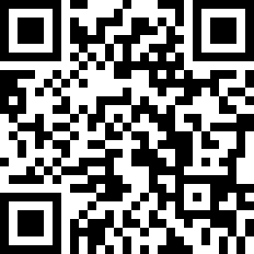
Choreographer: | Steve Cavanaugh (USA) - May 2021
Music: | What's the Point? - beaux
.

Music available on iTunes and Amazon
Start dance after 8 counts

[1-8] POINT-CROSS (2X), 1/8 PIVOT L (2X)
1-4 | Point R to Side, Cross R over L Moving Fwd, Point L to Side, Cross L over R
5-8 | Step Fwd R, Pivot 1/8 to Left, Step Fwd R, Pivot 1/8 to Left

[9-16] CROSS-POINT (2X), 1/8 PIVOT L (2X)
1-4 | Cross R over L, Point L to Side, Cross L over R, Point L to Side
5-8 | Step Fwd R, Pivot 1/8 to Left, Step Fwd R, Pivot 1/8 to Left

[17-24] WEAVE WITH POINT (2X)
1-4 | Cross R in front of L, Step L to Side, Step R behind L, Point L to Side
5-8 | Cross L in front of R, Step R to Side, Step L behind R, Point R to Side

[25-32] JAZZ SQUARE, POINT SIDE & CLOSE (2X)
1-4 | Cross R in front of L, Step L Back, Step R to Side, Step L in front of R
5-8 | Point R to Side, Step R Beside L, Point L to Side, Step L Beside R

Contact: steve@appleblossom.net

