A South-bound Train
.
.
Count: | 32 | Wall: | 2 | Level: | Beginner | .  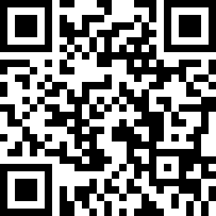
Choreographer: | Russibell Seoh (KOR) - October 2018
Music: | A South-bound Train (남행열차) - LPG
.

Intro : 32 Count

Restart : On Wall 3 ( Facing 12 : 00) & Wall 9 ( Facing 6 : 00 ) After 24 Count . Do not 1/4 R turn

Notice:-
Restart (At Wall3 & Wall 9 ) Section 3
SEC3. R Side Rock Recover Behind Side Cross, L Side Rock Recover Behind Side Cross.

Sec1. RF diagonally Fwd Shuffle , LF Digonally Fwd Shuffle Repeat
1&2,3&4 | RF RDiagonally FWd Shuffle(1:30) LF L Diagonally Fwd Shuffle(10:30)
5&6,7&8 | RF R Diagonally FWd Shuffle(1:30) LF L Diagonally Fwd Shuffle(10:30)

Sec2. Step Back , Sweep , Step Back Across Touch
1234 | RF Step Back(1) ,LF Sweep Around (2) LF Step Back (3) RF Sweep Around(4)
5678 | RF Step Back (5) Touch L Toe Across RF(6) ,LF Step Back(7) Touch R Toe Across LF(8).

Sec3. Side Rock Recover Behind Side Cross , Side Rock Recover Behind ,1/4 R Step FWD
12 3&4 | R Side Rock(1) Recover(2) Behind(3) Side(&) Cross(4),
56 7&8 | L Side Rock (5) RF Recover (6) LF Behind(7) 1/4 R Turn RF FWD Step(&)(Facing 3:00) LF Fwd Step(8)
Sec4. 1/4 R Jazz box , Side Point L HIp down &Clap, Hip Up down & Clap
1234 | RF Cross (1) 1/4 R Turn Step LF Back(2)(Facing 6:00), RF Side(3) LF Step Fwd(4)
56&,78& | RF side point ( The right knee is bent, and the left knee is straight)(5) Left Hip down& Clap(6) Hold and Clap(&) Right Hip Up (7) Left Hip Down and Clap(8) Hold and Clap(&)

Happy Dancing !!

Contact: lora3@naver.com

