Sunset Accompany Me Home
.
.
Count: | 32 | Wall: | 2 | Level: | Beginner | .  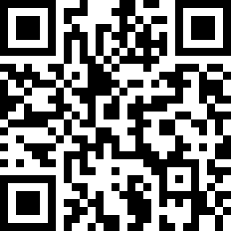
Choreographer: | Nina Chen (TW) - October 2017
Music: | Sunset Accompany Me Home (夕陽伴我歸) - Sarah Chen (陳淑樺)
.

Intro: 32 counts (Starting on vocal)

Sec 1: (R & L) SIDE TOUCH TWICE - VINE
1-2, 3&4 | Touch RF toe to R twice, Cross RF behind LF - Step LF to L - Cross RF over LF
5-6, 7&8 | Touch LF toe to L twice, Cross LF behind RF - Step RF to R - Cross LF over RF

Sec 2: FWD - PIVOT 1/4 L, CROSS SHUFFLE, SIDE ROCK - RECOVER, CROSS SHUFFLE
1-2, 3&4 | Step RF fwd - Pivot 1/4 turn L (9:00) weight on LF, Cross RF over LF - Step LF beside RF - Cross RF over LF
5-6, 7&8 | Rock LF to L - Recover on RF, Cross LF over RF - Step RF beside LF - Cross LF over RF

Sec 3: CHARLESTON (x2)
1-4 | Touch RF toe fwd - Step RF back - Touch LF toe back - Step LF fwd
5-8 | Touch RF toe fwd - Step RF back - Touch LF toe back - Step LF fwd

Sec 4: FWD - PIVOT 1/4 L, FWD SHUFFLE, FWD - RECOVER, COASTER STEP
1-2, 3&4 | Step RF fwd - Pivot 1/4 turn L (6:00) weight on LF, Step RF fwd - Step LF beside RF - Step RF fwd
5-6, 7&8 | Step LF fwd - Recover on RF, Step LF back - Step RF beside LF - Step LF fwd

Tag : After wall 3 & Wall 7 (6:00)
WALK AROUND FULL TURN R
1-4 | Step walk fwd on RF、LF、RF 、LF full turn R (6:00)

Have Fun & Happy Dancing !!!

Contact Nina Chen : nina.teach.dance@gmail.com

