Take My Breath
.
.
Count: | 32 | Wall: | 2 | Level: | Beginner | .  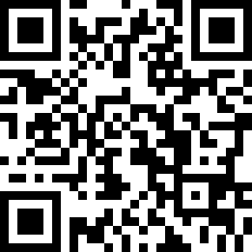
Choreographer: | David LECAILLON (FR) - September 2021
Music: | Take My Breath - The Weeknd
.

start after 64 counts

section 1 : walk R L, triple R foward, step L foward ½ turn R, triple L foward
1-2 | step Rf foward, step Lf foward
3&4 | step Rf foward, step Lf next to R, step Rf foward
5-6 | step Lf foward, ½ turn R 6:00
7&8 | step Lf foward , step Rf next to L, step Lf foward

section 2 : step R foward, together, triple R foward diagonaly, step L foward, together, triple L foward diagonaly
1-2 | step Rf foward on R diagonal, step Lf next to R
3&4 | step Rf foward on R diagonal, step Lf next to R, step Rf foward
5-6 | step Lf foward in L diagonal, step Rf next to L
7&8 | step Lf foward in L diagonal, step Rf next to L , step Lf foward

section 3 : step R foward ½ turn L, step R foward ½ turn L, R rocking chair
1-2 | step Rf foward, ½ turn L 12:00
3-4 | step R f foward, ½ turn L 6:00
5-6 | step Rf foward, recover onto Lf
7-8 | step Rf back, recover onto Lf

section 4 : kick ball step R, step R foward diagonaly touch L, kick ball step L foward, step L foward diagonaly , touch R
1&2 | kick R foward, ball Rf foward, step Lf foward
3-4 | step Rf foward on R diagonal, touch Lf next to R
5&6 | kick Lf foward, ball Lf foward, step Rf foward
7-8 | step Lf foward in L diagonal, touch Rf next to L

TAG 1 end wall 6 (4 counts) facing 12:00
step side touch x2
1-2 | step Rf on side , touch Lf next to R
3-4 | step Lf on side, touch Rf next to L

TAG 2 end wall 7 ( 8 counts) facing 6:00
step side touch x4
1-2 | step Rf on side , touch Lf next to R
3-4 | step Lf on side, touch Rf next to L
5-6 | step Rf on side , touch Lf next to R
7-8 | step Lf on side, touch Rf next to L

start again with smile

dadouchoregraphe@outlook.fr

