Dry Your Eyes
.
.
Count: | 32 | Wall: | 4 | Level: | Newcomer / Novice | .  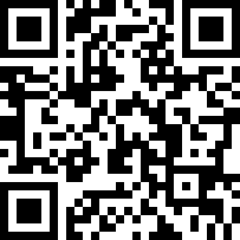
Choreographer: | Pim van Grootel (NL) & Bella Scholtzé - May 2011
Music: | Dry Your Eyes - Ben Saunders
.

Starts after: 16 Counts

Cross, Side, Heel, Ball, Cross, Side, Behind, Side, Heel, Cross
1 | RF Cross over LF
2 | LF Step to left side
3 | RF Heel diagonal right forward
& | RF Step next LF
4 | LF Cross over RF
5 | RF Step to right side
6 | LF Cross behind
& | RF Step to right side
7 | LF Heel diagonal left forward
& | LF Step next RF
8 | RF Cross over LF

Bounce ¼ Turn L 2x, Coaster Step, Step, Lock, Step 2X
1 | Bounce ¼ turn left (9.00)
2 | Bounce ¼ turn left (6.00)
3 | LF Step backwards
& | RF Step next LF
4 | LF Step forward
5 | RF Step forward
6 | LF Lock behind RF
& | RF Step forward
7 | LF Step forward
8 | RF Lock behind LF
& | LF Step forward

Step Fwd, ¼ Turn L, Touch Fwd, Touch Bwd, Syncopated Jazzbox
1 | RF Step forward
2 | LF ¼ Turn left stepping to left side (3.00)
3 | RF Touch diagonal left forward
4 | RF Touch diagonal right backwards
5 | RF Cross over LF
6 | LF Step backwards
& | RF Step to right side
7 | LF Cross over RF
8 | RF Step to right side

Sailor step L, Sailor step R ¼ Turn R, ½ Turn L, Step Fwd, ½ Turn L, ¼ Turn L, Drag
1 | LF Cross behind RF
& | RF Step to right side
2 | LF Step to left side
3 | RF Cross behind LF
& | LF Step to left side
4 | RF ¼ Turn right stepping forward (6.00)
5 | LF ½ Turn left stepping forward (12.00)
6 | RF Step forward
7 | LF ½ Turn left stepping forward (6.00)
8 | LF ¼ Turn left, drag RF towards LF (3.00)

Tag; After wall 3 doing the following steps:
Cross, Hold, Side, Close, Hold, 2x
1 | RF Cross over LF
2 | Hold
& | LF Step to left side
3 | RF Step next to LF
4 | Hold
5 | LF Cross over RF
6 | Hold
& | RF Step to right side
7 | LF Step next to RF
8 | Hold

