I See Your Face The Moon - Rumba
.
.
Count: | 32 | Wall: | 4 | Level: | High Beginner | .  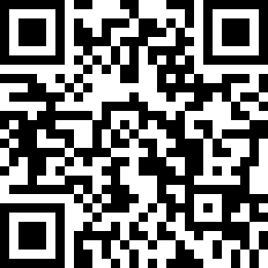
Choreographer: | Theo Seto Sundoro (INA) - November 2021
Music: | Diwajahmu Kulihat Bulan - Hendri Rotinsulu
.

Start on Lyric

S1: Side, Close, Lock Shuffle Forward, Side, Close, Chasse
1-2 | Step R to side, Close L Beside R
3&4 | Step R Forward, Lock L Behind R, Step R Forward
5-6 | Step L to Side, Close R Beside L
7&8 | Step L to Side, Close R Beside L, Step L to Side

S2 : Cross Rock, Turn ¼ Right Shuffle Forward, Cross, Side, Behind, HOLD
1-2 | Cross R over L, Recover on L
3&4 | Turn 1/4 Right Step R Forward, Step L Beside R, Step R Forward
5-6 | Cross L over R, Step R to Side
7-8 | Cross L Behind R, HOLD

S3 : Sweep, Turn 1/4 Left, Forward, HOLD, Forward, Pivot 1/2 Right , Forward, HOLD
1-2 | Sweep R Back Behind L, Turn 1/4 Left Step L forward
3-4 | Step R Forward, HOLD
5-6 | Step L forward, Turn 1/2 Right in Place on R
7-8 | Step L Forward, HOLD

S4 : Turn ¾ Left, Side, Cross, HOLD, Side, Close, Back Shuffle
1-2 | Turn 1/2 Left R Back, Turn 1/4 Left Step L to side
3-4 | Cross R over L, HOLD
5-6 | Step L to side, Close R Beside L
7&8 | Step L Back, Step R Back Beside L, Step L Back

Enjoy The Dance

