I See Love
.
.
Count: | 32 | Wall: | 4 | Level: | Beginner | .  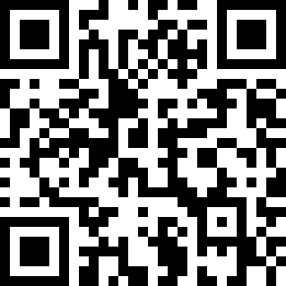
Choreographer: | Dwight Meessen (NL) - August 2018
Music: | I See Love (feat. Joe Jonas) - Jonas Blue : (Album: I See Love)
.

Intro: 16 counts

Out, Out, In, In, Pivot ½ L x2
1-2 | RF step right forward (out), LF step side (out)
3-4 | RF step back to center, LF step beside
5-6 | RF step forward, R+L ½ turn left
7-8 | RF step forward, R+L ½ turn left [12]

Diag Fwd, Lock, Step Lock Step Fwd (x2)
1-2 | RF step right forward, LF lock behind and lift R knee slightly
3&4 | RF step right forward, LF lock behind, RF step forward
5-6 | LF step left forward, RF lock behind and lift L knee slightly
7&8 | LF step left forward, RF lock behind, LF step forward [12]

Jazz Box ¼ R, Pivot ¼ L, Cross Shuffle
1-4 | RF cross over, LF ¼ right step back, RF step side, LF step forward
5-6 | RF step forward, R+L ¼ turn left
7&8 | RF cross over, LF step side, RF cross over [12]

Rock Side Recover, Behind - ¼ R Fwd - Fwd, Side, Touch Behind, Side, Touch Behind
1-2 | LF rock side, RF recover
3&4 | LF cross behind, RF ¼ right step forward, LF step forward
5 | RF step side, arms with index fingers up
6 | LF touch behind, arms with index fingers down
7 | LF step side, arms with index fingers up
8 | RF touch behind, arms with index fingers down [3]

Start again

TAG: After the 8th wall:
1 | RF rock side, shape with thumb and fingers R hand half a heart at face height
2 | hold
3 | LF recover, make the other half of the heart with thumb and fingers L hand
4 | hold

