I Left Something Turned On
.
.
Count: | 32 | Wall: | 2 | Level: | Newcomer | .  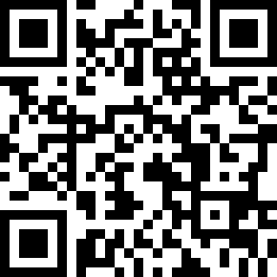
Choreographer: | Karolina Ullenstav (SWE) - August 2018
Music: | I Left Something Turned On At Home - Trace Adkins
.

Intro: 32 counts, BPM 151 - No Tags, No Restarts

Section 1: Side shuffle steps right and left ending with rock step back and recover
1 | RF step right (facing 12.00)
& | LF step right beside RF
2 | RF step right
3 | LF rock step back
4 | Recover onto RF (weight on RF)
5 | LF step left
& | RF step left beside LF
6 | LF step left
7 | RF rock step back
8 | Recover onto LF (weight on LF)

Section 2: Diagonal steps forward right and left with heel bounces and claps
1 | RF diagonal step forward right
2 | LF step beside RF
3 | Heel bounce with both feet and clap
4 | Heel bounce with both feet and clap
5 | LF diagonal step forward left
6 | RF step beside LF
7 | Heel bounce with both feet and clap
8 | Heel bounce with both feet and clap

Section 3: Step forward, touch, step in place , kick forward, step back, touch, step in place, kick forward
1 | RF step forward
2 | LF touch behind RF
3 | LF step in place
4 | RF kick forward
5 | RF step back
6 | LF touch in front of RF
7 | LF step in place
8 | RF kick forward

Section 4: Shuffle steps forward, shuffle turn ½ left, steps back
1 | RF step forward
& | LF step beside RF
2 | RF step forward
3 | LF step forward
& | RF step beside LF
4 | LF step forward
5 | RF turn ¼ left stepping right
& | LF step beside RF
6 | RF turn ¼ left stepping back (facing 06.00)
7 | LF step back
8 | RF touch beside LF

Have Fun!

