Blue Christmas
.
.
Count: | 64 | Wall: | 2 | Level: | High Beginner | .  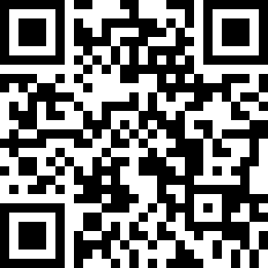
Choreographer: | Tina Chen Sue-Huei (TW) - December 2014
Music: | Blue Christmas - Jim Reeves
.

No Tag and No Restart
Start dance after 32 counts on the word “Blue”

S1. Rumba Box
1-2 | Side step R, step together L
3-4 | Back step R, hold on count (4)
5-6 | Side step L, step together R
7-8 | Fwd step L, hold on count (8)

S2. Step Fwd, Pivot Turn, Step Turn Together
1-2 | Step R fwd, ½ pivot turn left (6.00), weight on L
3-4 | Making a ½ turn left (12.00), step R beside L, hold on count (4)
5-8 | Sweep back L, sweep back R, sweep back L, touch R beside L

S3. Cross Recover Side Hold (2X)
1-4 | Cross R over L, recover on L, side step R, hold on count (4)
5-8 | Cross L over R, recover on R, side step L. hold on count (8)

S4. ¼ Turn Step & ½ Turn Step, Fwd, Hold
1-4 | Making a ¼ turn left (9.00), step fwd R, pivot ½ turn left (3.00), step fwd L, step fwd R, hold on count (4)
5-6 | Making a ½ turn right, step L back (9.00),
Making ½ turn right, step R fwd (3.00)
7-8 | Step L fwd, hold on count (8)

S5. Walk Fwd (3X), Kick, Step Hitch (2X)
1-4 | Walk fwd on RLR, kick on L
5-8 | Step back L, hitch in front on R, step fwd R, hitch behind on L

S6. Walk Back (3X), Touch, Side Kick (2X)
1-4 | Walk back on LRL, touch R beside L
5-8 | Side step R, kick L diagonally out, side step L, kick R diagonally out

S7. Side Together, ¼ Turn Step, Hold, Fwd, ½ Turn, Step, Fwd, Hold
1-4 | Side step R, step L together, making a ¼ turn right (6.00), step R fwd, hold on count (4)
5-8 | Step L fwd, making a ½ turn right (12.00), step on R, fwd step L, hold on count (8)

S8. Fwd & Point (2X), Fwd 1/2 Pivot Turn Step Fwd Together
1-4 | Step fwd R, point L to left, step fwd L, point R to right
5-8 | Step R fwd, pivot ½ turn left (6.00), weight on right, step L fwd, step R beside L

Start Again. - Happy Dancing.

Contact : sh3385@gmail.com

