Crossroads Of My Life 4-2 (P)
.
.
Count: | 32 | Wall: | 0 | Level: | Intermediate Partner | .  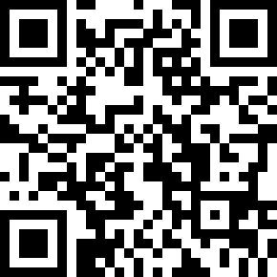
Choreographer: | Oliver Neundorf (DE) - December 2020
Music: | Crossroads - Andy Nickel
.

Note: The dance begins after 64 counts with the use of the song - no restart, 1 tag

Touch Behind, Pivot ½ r, Stomp 2, Step, Pivot ½ l, Walk 2
1-2 | Tap right toe behind left heel, ½ turn to the right on both pads Stomp
3-4 | 2 times with left foot next to right, weight at the end on the left
5-6 | steps with right, ½ turn left on both balls, weight at the end on the left
7-8 | 2 steps forward (r - l)

Rock Side r, Shuffle, Rock Side l, Shuffle
1-2 | Step to the right with right, lift left foot a little - weight back on the left foot
3&4 | Step forward with right - put left foot on right and step forward with right
5-6 | Step to the left with your left, lift your right foot a little - weight back on your right foot
7&8 | Step forward with left - put right foot next to left and step forward with left

Walk 2-Out-Out-In-In, Back 2, Rock Back
1-2 | 2 steps forward (r - l)
& 3 | Take a small step to the right with the right and to the left with the left
& 4 | Step back to the starting position with right and left feet to the right. move on
5-6 | 2 steps backwards (r - l)
7-8 | Step back with right, lift left foot a little - weight back on left foot

Woman: Step, Pivot ½ l, Step Pivot ½ l,
Man: Rocking Chair,
Woman / man: out, out, in, back
1-2 | F: Step forward with right - ½ turn to the left on both balls, weight at the end on the left (6 o'clock)
3-4 | F: Step forward with right - ½ turn to the left on both balls, weight at the end on the left (12 o'clock)
1-2 | M: Step forward with right, lift left foot a little - weight back on the left foot
3-4 | M: Step backwards with right, lift left foot a little - weight back on left foot
5-6 | Step diagonally to the right in front with right - small step to the left with left (only put on the hoe)
7-8 | Step back to the starting position with right - step back with left

Repeat until the end

Tag / bridge (after the end of the 12th round)
Hold 4
1-4 4 | beats (keep dancing on "Crossroads")

