My Redneck Friend
.
.
Count: | 64 | Wall: | 2 | Level: | Improver | .  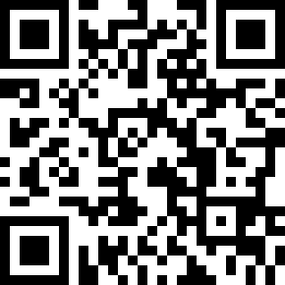
Choreographer: | Rob McKean (CAN) - May 2019
Music: | Redneck Friend - Jesse Dayton
.

Vine Right, Vine Left
1-4 | Step side right, cross L behind R, step side right, touch L beside R
5-8 | Step side left, cross R behind L, step side left, touch R beside L

Walk forward, Kick, Cross, Side, Behind, Side
9-12 | Walk forward R-L-R kick L forward
13-16 | Cross L over R, step side right, cross L behind R, step side right
½ Pivot, ¼ Pivot, Lindy Left
17-20 | Step forward on L, pivot ½ turn right, step forward on L, pivot ¼ turn right
21&22 | Step L to left, close R beside L, step L to left
23-24 | Rock back on R, recover onto L

Full Turn Left, Scuff, Left Rocking Chair
25-28 | Make a full turn left stepping R-L-R, scuff L forward
27-32 | Rock forward on L, recover on R, rock back on L, recover on R

Toe Touch Step, Repeat, Rock, Recover, ¼ Turn, Hold
33-36 | Touch L toe forward, step down on L, touch R toe forward, step down on R
37-40 | Rock forward on L recover on R, make a ¼ turn left stepping on L, hold

Toe Touch Step, Repeat, Rock, Recover, Back, Hold
41-44 | Touch R toe forward, step down on R, touch L toe forward, step down on L
45-48 | Rock forward on R, recover back on L, step back on R, hold
½ Turn Shuffle, Repeat, Coaster Cross, Hold
49&50 | Make a ½ turn left stepping L-R-L
51&52 | Make a ½ turn left stepping R-L-R
53-56 | Step back on L, step on R beside L, cross L over R, hold

Hip Bumps, Hip Rolls
57-60 | Bump hips right twice, bump hips left twice
61-64 | Roll hips counter clockwise twice.

Tag: Side Step & Touch, Repeat
1-4 | Step to right on R, touch L beside R, step to left on L, touch R beside L

The Tag is done at the end of Walls 3, 5,&7

