A Little Light On
.
.
Compte: | 32 | Mur: | 4 | Niveau: | Improver | .  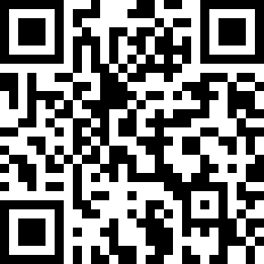
Chorégraphe: | Jef Camps (BEL) & Roy Verdonk (NL) - June 2021
Musique: | Afraid of the Dark - Chef'Special
.

Intro: 34 counts

S1: R Sailor Step, L Sailor Step, 1/8 Rock Fwd/Recover, Coaster Step
1&2 | RF cross behind LF, LF step side, RF step side
3&4 | LF cross behind RF, RF step side, LF step side
5-6 | 1/8 turn L & RF rock forward, recover on LF (10:30)
7&8 | RF step back, LF close next to RF, RF step forward

S2: Step, ½ Pivot, Shuffle ½ Turn, 1/8 Side, Hold, Ball, Side, Cross
1-2 | LF step forward, make ½ turn R while putting weight on RF (4:30)
3&4 | ¼ turn R & LF step side, RF close together, ¼ turn R & LF step back (10:30)
5-6 | 1/8 turn R & RF step side, hold (12:00)
&7-8 | LF close on ball next to RF, RF step side, LF cross over RF

S3: Side Rock/Recover, Crossing Samba, Cross, Side, Behind-Side-Cross
1-2 | RF rock side, recover on LF
3&4 | RF cross over LF, LF step side, RF step side
5-6 | LF cross over RF, RF step side
7&8 | LF cross behind RF, RF step side, LF cross over RF

S4: Chasse, ¼ Turn, Chasse ¼ Turn, Step, ¼ Pivot, Cross, Side
1&2 | RF step side, LF close next to RF, RF step side and make ¼ turn L on RF (9:00)
3&4 | LF step side, RF close next to LF, ¼ turn L & LF step forward (6:00)
5-6 | RF step forward, make ¼ turn L putting weight on LF (3:00)
7-8 | RF cross over LF, LF step side

Start again & have fun.

Restart: in wall 5, dance up to counts 14& (counts 6& of the 2nd section) and replace counts 15-16 with a
R side rock/recover before restarting the dance from the top. (12:00)

Last Update - 21 June 2021

